|  |  |  |
| --- | --- | --- |
| Course: | **Mobile Application Development LAB** | Date: 06/06/2024 |
| Course Code: | CSL-341 | Session: I |
| Faculty’s Name: | Dr. Muhammad Asif | Max Marks: 30 |
| Time Allowed: | 2.5 Hours | Total Pages: (5) |

**INSTRUCTIONS:**

1. This is Open Notes and book exam. Plagiarism is strictly prohibited.
2. All 3 questions are compulsory.
3. Be brief and to the point please.
4. VIVA will also be conducted of weightage 50%.

Student’s Name: Enroll No:

**Q No. 1: (2+2+2+2+2= 10 MARKS) (CLO-1)**

By recalling the **KNOWLEDGE** of **Google MAP API and SQLite of Android** by **DESCRIBING** the following Scenario of an App?

Make an android app using Google Map which displays the **CURRENT** location of your device. You have to use a google map activity. You have to write **.JAVA** file code and **PERMISSION** (ACCESS_FINE_LOCATION, ACCESS_COARSE_LOCATION and INTERNET) lines of code in MANIFEST.XML only. The GUI of an activity should be like as given below.

**Instructions/Requirements:**

1. **You should take Latitude and Longitude input from the user by adding two Edittext boxes on the activity with two Textviews i.e. Latitude and Longitude.**
2. **You should have two buttons i.e. Save to database and show Map.**
3. **You should use SQLITE database and JAVA code for this app. By using Try CATCH Block.**
4. **On button click event of SAVE, you should save the record in Database table by using INSERT query in SQLITE. You should also CREATE database and TABLE first (By using CREATE commands in SQLITE) when try to insert record in the database table on BUTTON SAVE. The database name should be unique for every student (E.g.** 01-134192-000**). Table name should also be unique for every student (E.g. full name of student, Muhammad Ali, Ayesha Khalid etc.).**
5. **On button click event of SHOW, you should retrieve the latitude and longitude values from the database table by using Select Query in SQLITE and show the GREEN colour Marker on the google Map.**

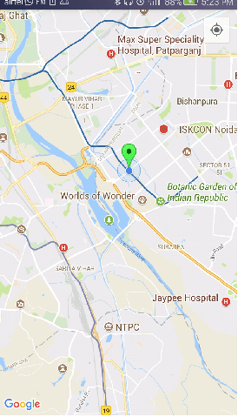

**Q No. 2: (2.5+2.5+2.5+2.5= 10 MARKS) (CLO-2)**

By **INTERPRETING** the concept of **JAVA Coding in Android Development,** Write a code for the following Scenario of an App?

Your task is to create an Android app for “Memory Calculator”, Calculator has only two operations, **MULTIPLICATION(*)** and **DIVISION(/)**, It will show entered value, operation and result at the designated places (as in below figure), additional feature of the calculator is to maintain history of last 5 results on the right side of the calculator.

**Instructions/Requirements:**

1. **You should use SQLITE database and JAVA code for this app.**
2. **You should save the history of 5 records in Database (i.e. Already created DB in Question#1. You need not to create DB again) table (i.e. Separate table HISTORY should be created in DB) by using INSERT query in SQLITE. Table name should also be unique for every student (E.g. full name of student, Muhammad Ali_History, Ayesha Khalid_History etc.).**
3. **On button click event of SHOW, you should retrieve the History values from the database table by using Select Query in SQLITE and show the values below the SHOW History button.**
4. **You should use TRY, CATCH block and implement Exception Handling of DIVIDE BY ZERO ERROR!**

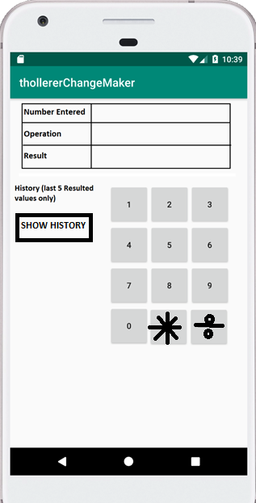

**Q No. 3: (2.5+2.5+2.5+2.5= 10 MARKS) (CLO-3)**

**UNDERSTAND** the following problem statements and **SOLVE** by using **Logic**/Problem Solving Skills.

Your task is to create a **TOAST FLUTTER** App in Android Studio or Microsoft VS Code by using **DART** Language.

**Instructions/Requirements:**

1. **You should use PUBSpec.Yaml file to add dependency.**
2. **You should make a STATEFUL Widget.**
3. **Use Try Catch Block.**
4. **Following properties should be there.**

* **msg:** Toast message
* **toastLength:** Toast message duration
* **backgroundColor:** Background color to be shown
* **textColor:**  Text color to be shown
* **fontSize:** Toast Message font size
* **gravity:**  Toast message location

**Best of Luck**